**IST 263 Exam 2 Guide**

**General Procedures and Format**

* closed book
* on paper
* will include a syntax sheet
* 20 multiple choice questions worth 4 points each
* 4 short answer questions worth 5 points each
* the short answers could be writing HTML, CSS or   
  writing a few sentences to explain a concept

**Tips**

Use the review questions in blackboard to prepare.

**Exam Topics**

* ***Lesson 5 – Photoshop  
  png vs jpg vs gif – what's the difference?, why resize in photoshop***

1. JPEG works best for storing full-color images full of complex shading and color variation. PNG is mostly superior to GIF, as it is newer, supports more colors, and is free of patent restrictions. PNG cannot be used for animation, but offers highly sophisticated transparency and color support, among other features. Resize in photoshop lets you adjust pixels, as well as, do other things like resize a certain part of your image and other little details that simply adjusting width/height doesn’t.

-------------------------------------------------------------------------------------------------------------------------------

* ***Lesson 6 – CSS Intro and Wireframes  
  wireframe, embedded/external/inline styles, class selector, element selector, id selector, grouped selector, text properties, inheritance, units of measure***

Wireframe allows us to design basic layout of a website without thinking abt design. Helps focus on UX

CSS = standard for defining presentation of HTML

CSS Rule: selector {property: value}

3 different ways to add CSS

* Linked/external = aka adding CSS through linked/external stylesheet
* Embedded or internal = aka CSS added at the top of our HTML page
* Inline = aka CSS that is added in the elements of the body tag (we don’t use bc it causes confusion)

Units of measure:

**Absolute – have predefines meanings or real-life equivalents. They are not appropriate for web pages. Aka px (pixels, in (inches)**

**Relative – based on the size of something else, such as the default text size. Aka em (2em means 2 times the size of the current font)**

Inheritance:

**Head**

* **Title**
* **Style**
* **meta**

**head**

**body**

* **h1,h2,h3,etc**
* **p,p2,p3, etc – em, img**

**body**

* Group selector = p, ul, td, th { color:navy }
* Id selector = #myheading { color:pink }
* Class selector: .myclass { color:grey }
* Element selector = p { color:navy }
* Descendanct selector = p a { color:orange }  
   -------------------------------------------------------------------------------------------------------------------------------
* ***Lesson 7 – More CSS, Box Model and Site Maps  
  web development lifecycle, style document (not stylesheet), hex color, pseudo selector, descendant selector, box model***

***#RRGGBB (RR*** hex red value) (***GG*** hex green value) (***BB*** hex blue value)

Hexadecimal RGB values are used bc more options/variations + quicker load on the web

***Pseudo selector***

* a:link { color:maroon; }
* :hover – applies when the mouse pointer is over the element
* Body {background-image: url(“paper.gif)}
* Element box contains content, padding, and margin
* Applies a style to a state of an element
  + What does an element look like when your mouse is over it
  + What does an element look like after it’s been clicked
  + What does a form filed look like when it is the one you are using

-------------------------------------------------------------------------------------------------------------------------------

* ***Lesson 8 – CSS Layout, Semantic Tags, semantic elements, div, span, floats, clearing floats, flexbox***

***Semantic tags:***

* Article, Aside, Footer, Header, main

***Non-semantic tags:***

* Div, span

Float – an element pushed to left or right allowing everything after the element to wrap around it

* .img {float:left}
* Div {clear:both}

To clear a float, use the clear CSS property

Flexbox – a way of laying out elements on a web page

* Elements/containers are laid out in rows and columns
* Flex container – the parent element
* Flex items – the child elements

Properties of a flexbox

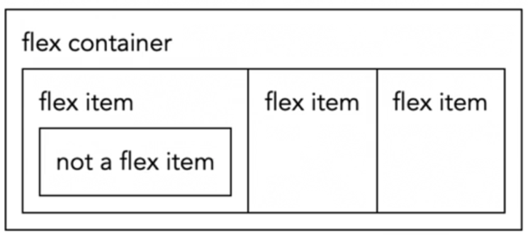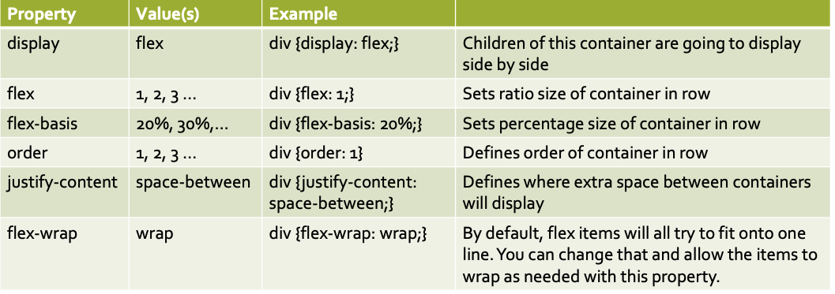

-------------------------------------------------------------------------------------------------------------------------------

* ***Lesson 9 – Centering inline elements, block containers, and centering using flexbox justify-content. Advanced layout with nested flexboxes and justify-content.***

***Centering inline elements = {text-align: center}***

***Block elements take up 100% of the page by default, so one must set a width or it wont look like anything happened***

***{width: 30%;***

***Margin: 0 auto;}***

-------------------------------------------------------------------------------------------------------------------------------

* ***Lesson 10 – Responsive Design and Media Queries  
  viewport meta tag, flexible sized images, wrapping flexbox, media queries***

-------------------------------------------------------------------------------------------------------------------------------s